ASSIGNMENT 1

Ans. 1) Frontend is the part of web development that focuses on UI and interactive part of the website or web application. It includes designing the layout, buttons and animations.
HTML, CSS are used for this. Ex : When you open Amazon, you see search bar, products buttons, that are part of frontend only.
Backend handles the logical part of Website or Web Application. It processes all the requests connects with databases and return the data to frontend.
Java, Python are used for this. EX : When you login in Instagram, backend verifies all details before access to your account.
Full Stack Development works both combined. It can build complete websites or web applications.
HTML, CSS, JS, Python, MongoDB can be used. EX : A Freelancer creating a shopping website for a client.

Ans. 2) 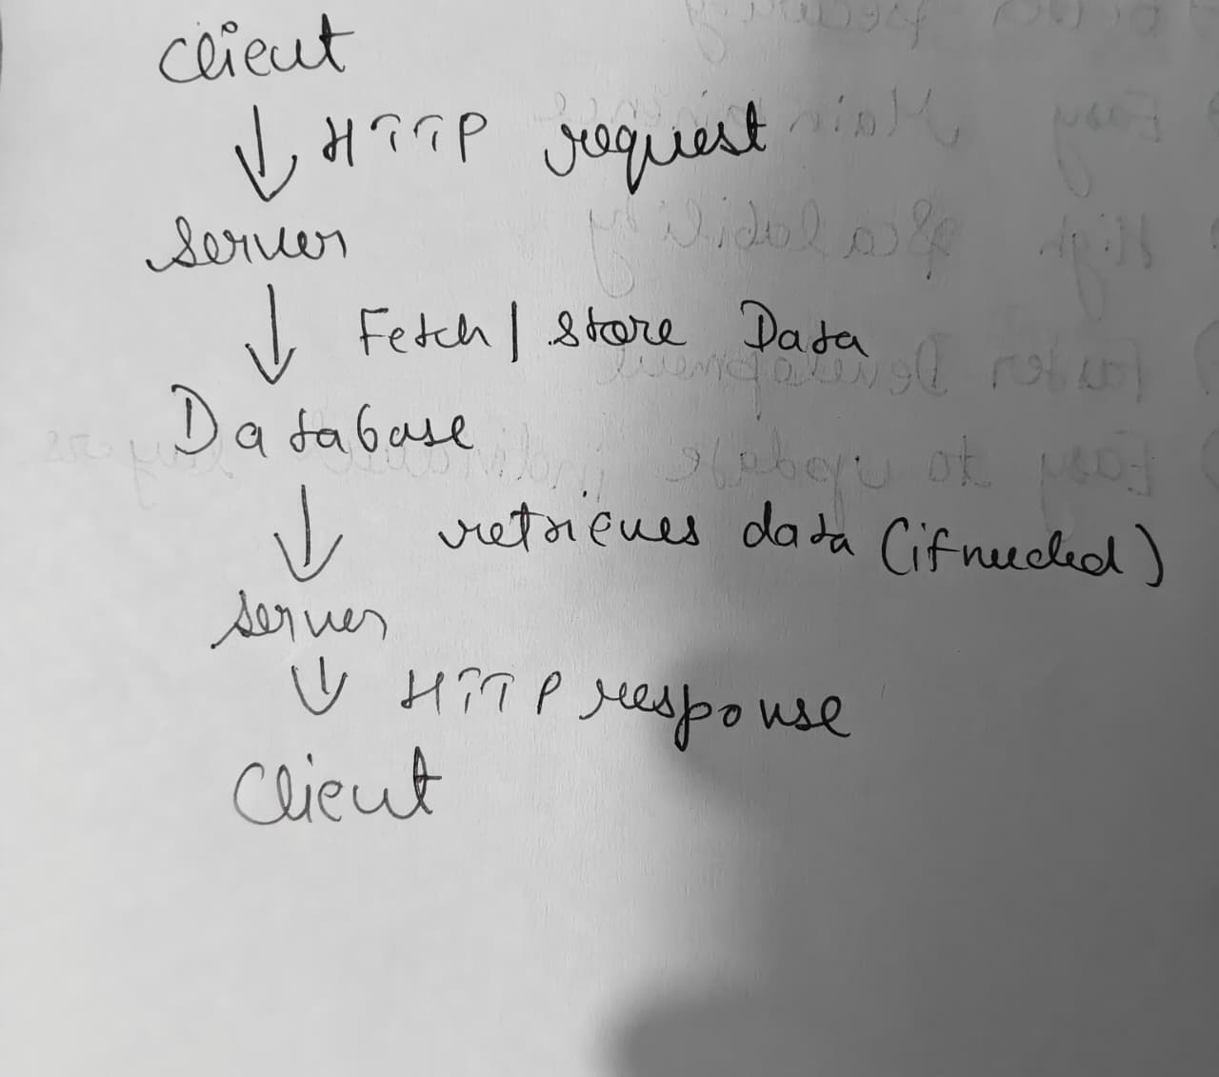

Ans. 3) User types a Url in a browser -> HTTP Request -> web server takes the request, contacts the database if needed -> server generates a response -> browser then shows the result

Ans. 4) VS Code -> For Writing and editing the code
Browser (Chrome) -> Testing the Website
GitHub -> For Storing Project online
HTML, CSS, JSS -> For Coding

Ans. 5) A web server is a program that stores website files and gives them when users request them through a web browser. Commonly used servers are Apache HTTP server and Microsoft IIS.

Ans. 6) Frontend Developer -> They design the website layout, create responsive pages, develops user interface and improves user experience.
Backend Developer -> They develop Server Side logic, create api’s and connects with databases. They also focuses on authentication of users.
Database Administrator -> They design databases, stores and manages data on database, improves database performance and maintains security.
Ans. 7) 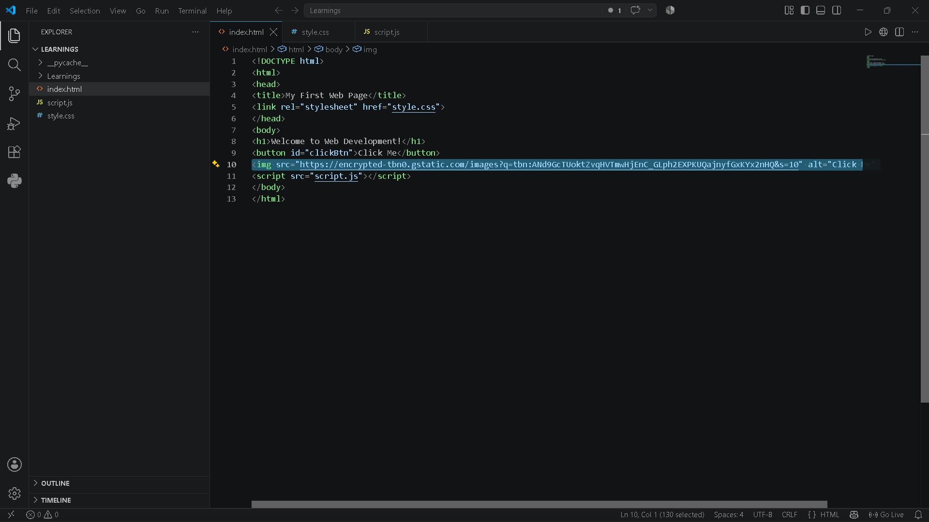

Ans. 8) Static Website -> A static website contains fixed content. User cannot update the website data unless data is updated by the developer.
Ex – A personal portfolio website.
Dynamic Website -> A dynamic website generates content based on user requests or database information.
Ex – Facebook, Instagram

Ans. 9)
Google Chrome – rendering engine is Blink
Microsoft Edge – Blink
Mozilla Firefox – Gecko
Safari – Webkit
Opera – Blink
A rendering Engine is responsible for converting HTML, CSS, JS into website
Visible on screen.
Blink – Fast performance, supports modern web technologies.
Gecko – Open Source engine, focuses on web standards.
WebKit – Optimized for Apple devices and energy efficient

Ans. 10)
USER -> Web Browser -> HTTP Request -> Web Server
|
----|----
| |
API Server Database
| |
-----|-----
|
HTTP response <- Web Server <- Process Response
|
Browser displays Web Application

